* CB FSD - Integration and Deployment

Day 2 : 9 July 2024

Creating docker image to run spring boot application

Using spring initializer create spring boot project with single starter ie web starter

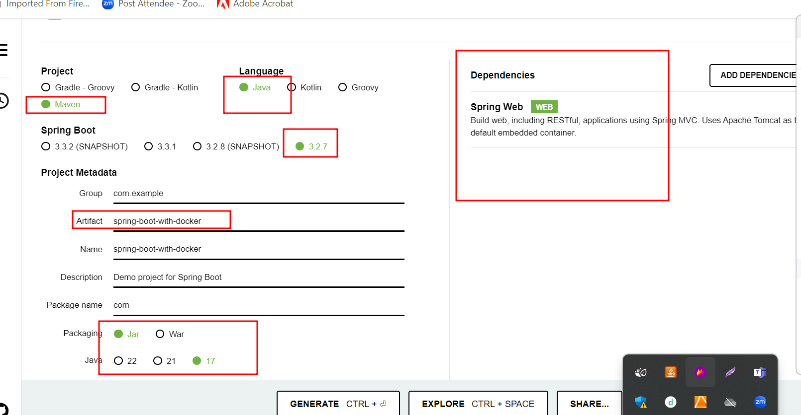

Create more than one end point and using Eclipse IDE create the jar file with the option run 🡪 maven install.

Then create the Dockerfile

FROM openjdk:17

COPY ./target/spring-boot-with-docker-0.0.1-SNAPSHOT.jar .

CMD ["java","-jar","spring-boot-with-docker-0.0.1-SNAPSHOT.jar"]

Now we need to build the image.

docker build -t my-spring-boot . -f Dockerfile